Ex1:

<?xml version="1.0"?>

<student>

<firstname>ruma</firstname>

<lastname>jaiswal</lastname>

<email>rumajaiswalh.2016.it@ritchennai.edu.in</email>

</student>

Output:

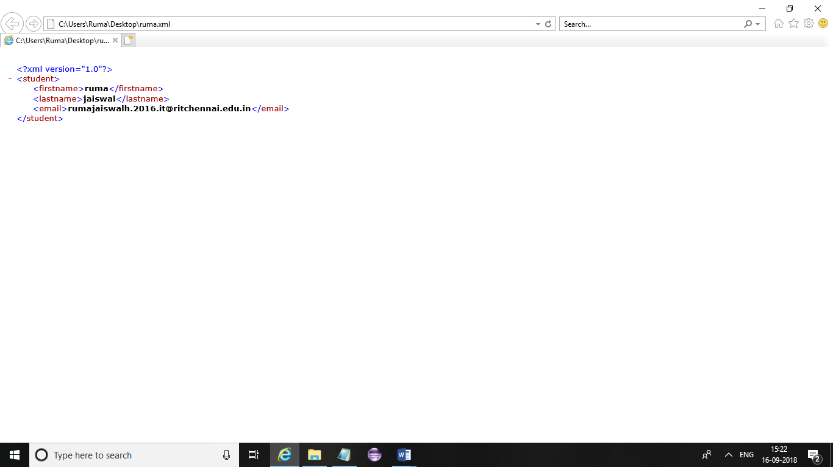

Result:

Ex2:

Xml:

<?xml version="1.0"?>

<?xml-stylesheet type="text/css" href="new.css"?>

<!DOCTYPE employee SYSTEM "employee.dtd">

<employee>

<heading>LIST OF STUDENTS</heading>

<br />

<br><text1>ruma</text1> <br/>

<br><text2>shanu</text2> <br/>

<text3>priya</text3>

<text4>anu</text4>

<heading>SELECTED CANDIDATES</heading>

<text1>shanu</text1>

<text2>ruma</text2>

</employee>

Css:

employee

{

background-color: thistle;

}

text1,text2,text3,text4

{

font-size:20px;

display:block;

color: tomato;

margin-left: 50px;

}

heading

{

font-size:35px;

display:block;

color:black;

}

Dtd:

<!ELEMENT employee (text1,text2,text3,text4)>

<!ELEMENT text1 (#PCDATA)>

<!ELEMENT text2 (#PCDATA)>

<!ELEMENT text3 (#PCDATA)>

<!ELEMENT text4 (#PCDATA)>

Output:

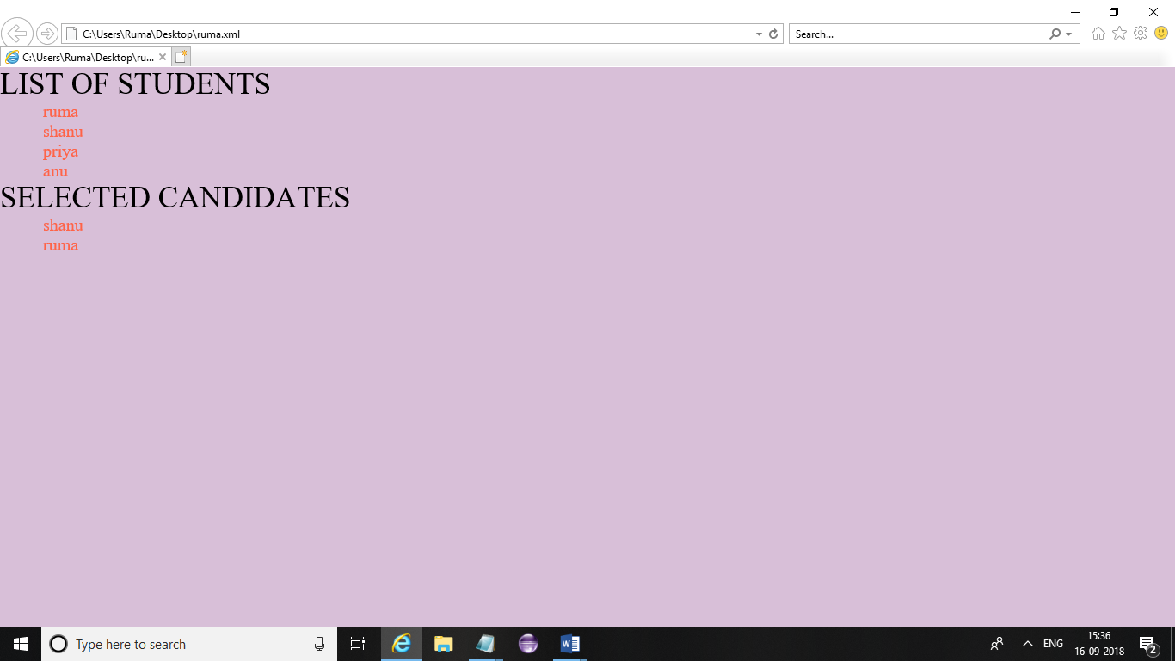

Result:

Ex3:

Xml:

<?xml version = "1.0"?>

<?xml-stylesheet type = "text/xsl" href = "my.xsl"?>

<class>

<employee id = "001">

<firstname>ruma</firstname>

<lastname>siya</lastname>

<nickname>neha</nickname>

<salary>30000</salary>

</employee>

<employee id = "024">

<firstname>shan</firstname>

<lastname>mugi</lastname>

<nickname>Zoya</nickname>

<salary>25000</salary>

</employee>

<employee id = "056">

<firstname>crystal</firstname>

<lastname>dsouza</lastname>

<nickname>Danny</nickname>

<salary>10000</salary>

</employee>

</class>

Xsl:

<?xml version = "1.0" encoding = "UTF-8"?>

<xsl:stylesheet version = "1.0"

xmlns:xsl = "http://www.w3.org/1999/XSL/Transform">

<xsl:template match = "/">

<html>

<body>

<h2>Student</h2>

<table border = "1">

<tr bgcolor = "green">

<th>ID</th>

<th>First Name</th>

<th>Last Name</th>

<th>Nick Name</th>

<th>Salary</th>

</tr>

<xsl:for-each select="class/employee">

<tr>

<td>

<xsl:value-of select = "@id"/>

</td>

<td><xsl:value-of select = "firstname"/></td>

<td><xsl:value-of select = "lastname"/></td>

<td><xsl:value-of select = "nickname"/></td>

<td><xsl:value-of select = "salary"/></td>

</tr>

</xsl:for-each>

</table>

</body>

</html>

</xsl:template>

</xsl:stylesheet>

Output:

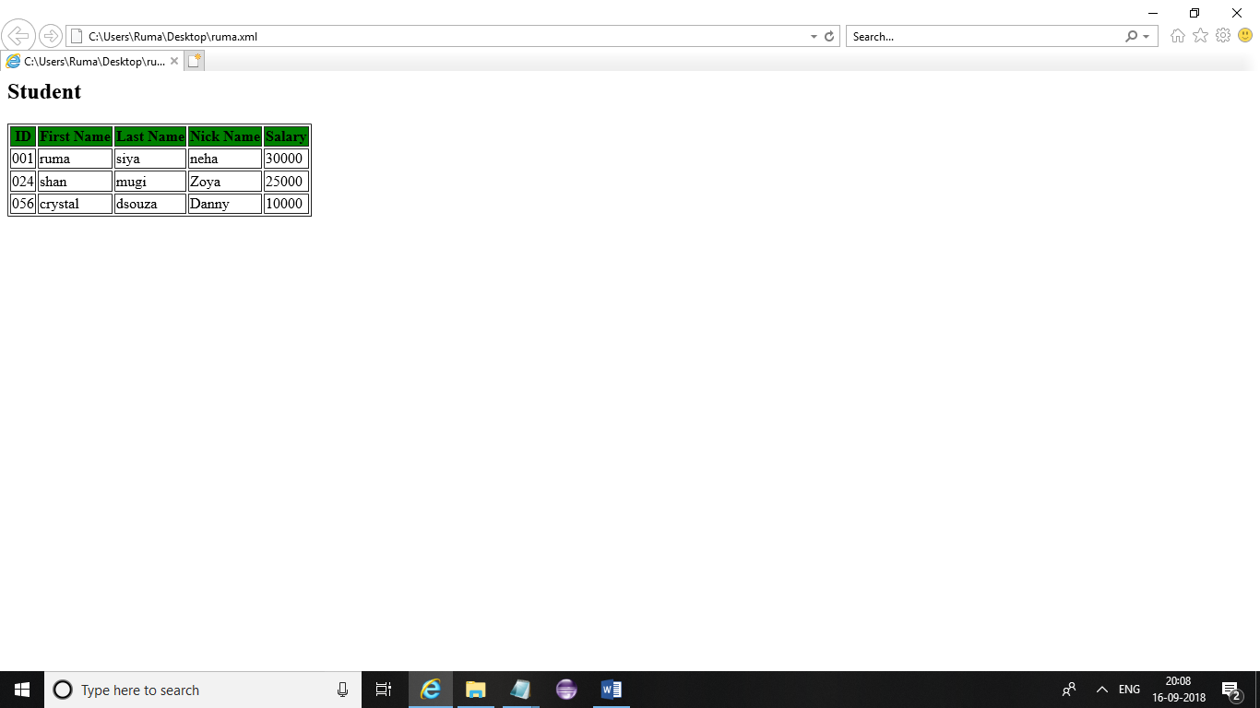

Result:

Ex4:

Xml:

<?xml version = "1.0"?>

<?xml-stylesheet type = "text/xsl" href = "my.xsl"?>

<class>

<employee id = "001">

<name>ruma</name>

<email>rumajaiswal24@gmail.com</email>

<score>80</score>

</employee>

<employee id = "024">

<name>shanu</name>

<email>shanupriya@gmail.com</email>

<score>56</score>

</employee>

<employee id = "056">

<name>siya</name>

<email>siyason@yahoo.com</email>

<score>96</score>

</employee>

</class>

Xsl:

<?xml version = "1.0" encoding = "UTF-8"?>

<xsl:stylesheet version = "1.0"

xmlns:xsl = "http://www.w3.org/1999/XSL/Transform">

<xsl:template match = "/">

<html>

<body>

<h2>Student Table</h2>

<table border = "2">

<tr bgcolor = "yellow">

<th>ID</th>

<th>Name</th>

<th>email</th>

<th>Score</th>

<th>Comments</th>

</tr>

<xsl:for-each select = "class/employee">

<tr>

<td><xsl:value-of select = "@id"/></td>

<td><xsl:value-of select = "name"/></td>

<td><xsl:value-of select = "email"/></td>

<td><xsl:value-of select = "score"/></td>

<td>

<xsl:choose>

<xsl:when test = "score > 80">

Above Average

</xsl:when>

<xsl:when test = "score > 60">

Average

</xsl:when>

<xsl:otherwise>

Below Average

</xsl:otherwise>

</xsl:choose>

</td>

</tr>

</xsl:for-each>

</table>

</body>

</html>

</xsl:template>

</xsl:stylesheet>

Output:

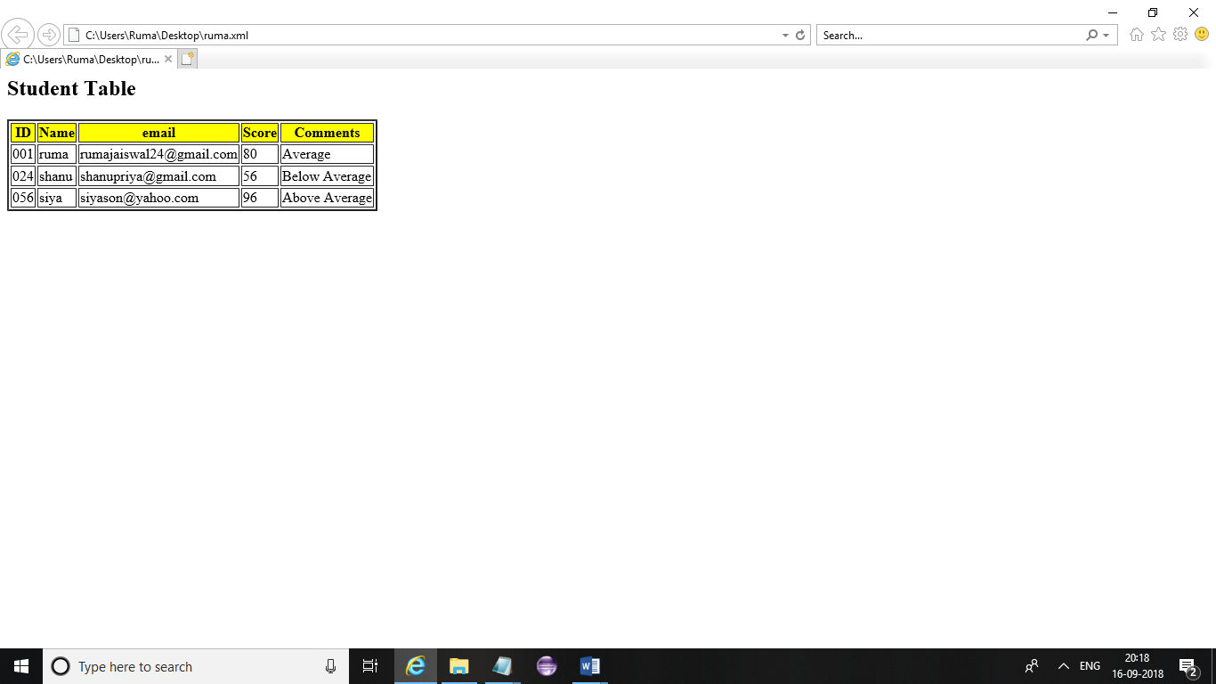

Result:

Ex5:

Xml:

<?xml version = "1.0"?>

<?xml-stylesheet type = "text/xsl" href = "my.xsl"?>

<class>

<employee id = "001">

<name>ruma</name>

<email>rumajais@gmail.com</email>

<score>80</score>

</employee>

<employee id = "024">

<name>siya</name>

<email>siya26@gmail.com</email>

<score>56</score>

</employee>

<employee id = "056">

<name>Shane</name>

<email>shaneson@yahoo.com</email>

<score>96</score>

</employee>

</class>

Xsl:

<?xml version = "1.0" encoding = "UTF-8"?>

<xsl:stylesheet version = "1.0"

xmlns:xsl = "http://www.w3.org/1999/XSL/Transform">

<xsl:template match = "/">

<html>

<body>

<h2>Student Analysis</h2>

<xsl:apply-templates select = "class/employee" />

</body>

</html>

</xsl:template>

<xsl:template match = "class/employee">

<xsl:apply-templates select = "@id" />

<xsl:apply-templates select = "name" />

<xsl:apply-templates select = "email" />

<xsl:apply-templates select = "score" />

<br />

</xsl:template>

<xsl:template match = "@id">

<span style = "font-size = 25px;">

<xsl:value-of select = "." />

</span>

<br />

</xsl:template>

<xsl:template match = "name">

First Name:<span style = "color:thistle;">

<xsl:value-of select = "." />

</span>

<br />

</xsl:template>

<xsl:template match = "email">

email:<span style = "color:yellow;">

<xsl:value-of select = "." />

</span>

<br />

</xsl:template>

<xsl:template match = "score">

Marks:<span style = "color:red;">

<xsl:value-of select = "." />

</span>

<br />

</xsl:template>

</xsl:stylesheet>

Output:

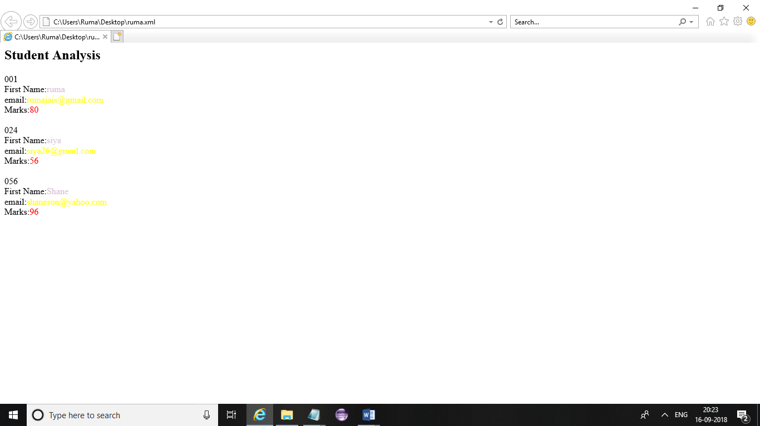

Result: